Addis Ababa University
Science Faculty
Department OF MATHEMATICS
Math 231: Applied Mathematics
Mid-Semester Examination

Date:
Time:

Name: _____________________________ I.D. No. _________________
Department: _________________________
Instructor: Dr. Daniel Falk Dr. Yirgalem Tsegaye
Part A: Answer al the questions

1. 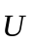 = i – 2j + 3k = 3j + k
Compute Y.U
2. Using and in problem 1,
Compute ×
3. and in problem 1,
Compute || v ||
4. If and are non-ziro vectors, Find α so that
- α is Orthogonal to U. α = __________________
- Using the Formula you got for α in problem 4,
v = 12i + 9j – 5k, u = 4i + 3j – 5k, find the value of α such that v – αu is orthogonal to u.
- Given 3i + 5j – 3k = -i – 2j + 3k w = 2i – j + 4k
Proj u =
v – zw

- If v, u, w are linearly independent vectors is there a scalar α such that
w = - α? Yes/No/subjective

8. For any vectors and
(||v||u + ||u||r) . (||v||u - ||u||r) = ____________________
9. v = (1, 2, 3) u = (4, 3, -1) w = (-5, -3, 5) v = (-2, 1, 6)
The values of α and β such that α (u + v) + β(w + r) = 0
are α ________________ β = ________________
10. Using, v, u, w, r in problem 9, is there an α such that
v + u = α (w + r)? If Yes, α = _____________
11. Given the points
D = (-2, 3, 1) Q = (1, 2, 3) R = (3, -1, z) in ℜ³
the area of ΔPQR is equal to ________________
12. If = α for some vectors and 100 ℜ³.
The for some scalar β, × β = ____________________.
13. For three vectors u, v, w in ℜ³ such that v = u – w,
v(u × w) __________________
- Let W = {(4 – zr, r) | y ∈ℜ} Then w with the usual vector addition and scalar multiplications for vectors in ℜ² is a vector space (True, False) ___________.
- If ⟨ v, w ⟩ = span of {v, w}, then
⟨(1, 2), (3, 5) ⟩ = ________________________
- Write the parametric Equations of the line , passing through the points:
p = (8, 3, 2) Q = (z, -3, 5)
17. How far is the point R = (5, 0, 3.5) from , in problem 16?
18. How far is the point S = (4, 1, 6) from , in problem 16?
19. Find the intersection of the line  given by
(x – 3) = t y + 2 = 3t, z = 4t – 1 and the
Plane π given by: x – 2y + z = 6 _______________________
- Given the points A = (6, 2, 4) B = (1, -2, 3) and C = (6, 4, 10). Find A unit normal the plane containing A, B, and C.
- Normal Equation of the plane in problem 20 is:
- Suppose A is an invertible matrix of order 5 and Det (A) = 2, and α is a non-zero scalar. Find Det (αA⁻¹)
- let A be A square matrix with linearly independent Rows. Is A invertible? ___________________ (Yes, No, Sometimes)
- Using the matrix A in problem 23, How many solutions does the system of linear equations given by the matrix equation:
AX = B, X = 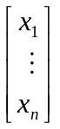 B = 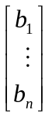 have? ______________
(Infinitely many, no solution, exactly one solution)
- What should be the value of a, so that the system of liner equations,
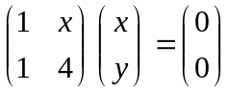 have infinitely many shows?

Workout
1. Do the lines (5 points)
₁: 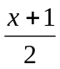 = 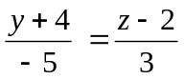
₂: 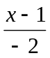 = 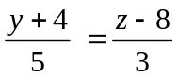
Intersect? If yes find the intersection point
- Solve the following system of linear equations for x, y, z using cramer’s rule: (5 points)
2x + 4y + z = -7
x – 3y – 2z = -1
3x + 9y + z = 6
- Find the inverse of the matrix A = 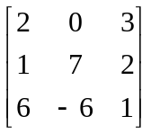 (5 points)

